Data Technician Week 5
Workbook
Azure Data Fundamentals

Name:
Course Date:
Table of contents
Day 1: Task 1 3
Day 1: Task 2 4
Day 1: Task 3 5
Day 2: Task 1 6
Day 3: Task 1 10
Day 3: Task 2 11
Day 3: Task 3 12
Day 4: Task 1 13
Day 4: Task 2 14
1. Scenario Background 14
2. Data Laws and Regulations 14
3. Azure Service Recommendations 14
4. Data Types and Data Modelling 14
5. Data Storage Formats and Structures in Azure 15
6. Additional Considerations 15
Submission Guidelines: 15
Course Notes 18
Additional Information 19

Day 1: Task 1

Please research and complete the below questions relating to key concepts of cloud.

Be prepared to discuss the below in the group following this task.

What can cloud computing do for us in the real-world? | Cloud computing delivers on-demand IT resources over the internet, enabling businesses, governments, and individuals to access scalable services without heavy infrastructure investments. Cloud also enables online data storage which allows an organisation or individual to store videos or images/ files without the need for an expensive physical storage system.
How can it benefit a business? | Cloud Computing can benefit a business by saving costs by reducing the need for businesses to invest in physical hardware and infrastructure.
What’s the alternative to cloud computing? | Alternatives to cloud computing is Fog Computing. Fog computing is a decentralized computing infrastructure that processes data closer to the source rather than relying solely on centralized cloud servers.
What cloud providers can we use, what are their features and functions? | Features AWS Azure GCP  Offers a vast ecosystem with over 200 services such as computing power, storage options and networking Provides a wide array of services including AI, Data analytics and DevOPs tools. Focuses on big data solutions, Focuses on Data analytics and machine learning capabilities.

Day 1: Task 2

Please research the below cloud offerings, explain what they are and examples of use cases.

Cloud Offerings | Explain what it is | When / how might you use this service in the real-world?
IaaS (Infrastructure as a service) | A cloud computing model providing on demand virtualized it resources such as security, storage and networking on a pay as you go basis. | For example retailers can use iaas to dynamically scale server capacity during peak seasons i.e Black Friday. This ensures consistent performance without buying permanent hardware.
PaaS (Platform as a service) | A cloud computing model providing a complete ready to use environment | Paas can be used for many things i.e an e commerce store. It can be used to create and setup an online shop with built in and managed infrastructure. Paas is used to accelerate software development and cut costs by providing pre configured environments.
SaaS (Software as a service) | This is a cloud based software delivery model where people access applications over the internet | An example of saas could be platforms like shopify or Netflix. For example saas is accessible from multiple devices without much interference needed. It will automatically update by itself and is often very open to collaboration as in multiple users can use the service at the same time. SaaS is often a subscription model weather that would be paying monthly or yearly it is very consumer friendly.

Day 1: Task 3

Please research the below terms and explain what they are, when they would be appropriate and a real-world example of where it could be implemented (i.e. what type of organisation).

Public Cloud | Public cloud is where services like applications and storage are provided over the internet by a thirdparty company. Systems and hardware are owned and managed by the provider and multiple customers share the same infrastructure. Its appropriate when a business wants a solution where its low cost, flexible and simple. The business doesn’t manage its own servers therefore this works well for startups or small businesses that need to scale quickly.  Real-world example: A small online clothing store using services from a company like Amazon Web Services (AWS) to host its website and store customer data.
Private Cloud | Private Cloud is used by one organisation. Servers and infrastructures are not shared with other companies, it can be located onsite or hosted by a third party yet it is only dedicated to one organisation.  Its appropriate when a company needs more control/ high security and when that company needs to follow strict and set regulations. I.e a rather large organisation would choose this such as a Bank. Its prone to store more sensitive and information securely.
Hybrid Cloud | Hybrid cloud combines both previously mentioned, Public and Private systems. An organisation can use hybrid to keep sensitive data in a private cloud but still use the public cloud for less important information or tasks .  This would be appropriate when a company wants both flexibility and security.  Real-world example: A hospital storing patient records in a private cloud for security, but using the public cloud to run its website or appointment booking system.
Community Cloud | Community cloud is pretty straight forward, It is a cloud that is shared by several organisations all with the same needs or regulations. i.e the same security requirements. This infrastructure is shared but only to those specific organisations. This is appropriate when organisations all in the same sector want to share costs whilst still meeting common compliance rules  Real-world example: Several government education departments sharing a cloud system designed specifically for public sector organisations.

Day 2: Task 1

Describe, with examples, the three major areas that the Computer Misuse Act deals with.

Area | Description | Example
Unauthorized access to computer materials | This involves gaining access to a computer system or data without permission, it is considered basic hacking. Doing so committing this offense can include fines and imprisonment for up to 2 years | Accesses data, systems, or networks without permission or beyond the level of access they are allowed.  i.e an ex employee still has their old login credentials.
Unauthorized access with intent to commit further offenses | This is when an individual gains unauthorized access to a computer system with the pure intention of committing crime i.e fraud theft. Doing so will lead to more serious consequences which could be up to 5 years imprisonment and heavier fines. | Gaining unauthorized access to a computer system with the intention of committing another crime, such as fraud, theft, or data misuse.  i.e Hacking a company system to access and steal data. The Intention is clearly crime focussed and they have also gained unauthorized access.
Unauthorized modification of computer material | This is accessing computer materials with the intent of altering or destroying data without authorization. i.e deleting files. Depending on the severity this can lead up to 5 year imprisonment and unlimited fines. | A person deliberately changes, deletes, or interferes with computer data or systems without permission.  i.e a finance employee altering company payment records. For example editing payment amounts or changing bank details.

The computer misuse act 1990 is an act where an individual can be criminalised because of computer related offense. Describe three extra powers that the Police and Justice Act 2006 (Computer Misuse) has added.

Description
Power to prosecute acts before they happen. This allows earlier intervention before the actual damage is caused.

Increased maximum penalties meaning the more serious the offence is the higher the sentence will be.

Expanded scope of section 3
The Act broadened the offence of unauthorized modification to include:
- Acts impairing the operation of a computer
- Preventing or hindering access to data
- Denial-of-service (DoS) attacks
This allows prosecution of service disruption even if the data was not modified.

Look at the below website to answer the questions:
https://www.gov.uk/personal-data-my-employer-can-keep-about-me

Write down three items of data which a company can store about an employee.
The first item of data a company can store about an employee is Their Name

The second is there employment history

Thirdly their national insurance number

Give three more examples of data that an employer can only store if they first get the employee’s permission.
Religion

Genetics

Health and medical conditions

Conduct further research to answer the below questions.

Question | Answer
Provide one example of: Copyright infringement | Uploading a movie without permission. i.e downloading a newly released film and displaying it elsewhere. The film is owned by the studio, therefore going ahead and releasing it elsewhere violates the studios copyrights
Provide one example of: Plagiarism | Someone presents another person’s words, ideas, or work as their own without proper acknowledgment.  I.E copying another employees work reports.
What are two consequences of copyright infringement and software piracy? | Legal consequence – criminal prosecution, fines  Business and financial consequences- Loss of revenue. Operational risks
Give three possible consequences for individuals when using pirated software | Functional and Operational issues i.e a pirated word processor could corrupt docs  Security risks. Personal data such as banking details could be stolen.  Legal consequences. Downloading or distributing unlicensed software could lead to action in court.

Listed below are some laws which we have covered today:

1. Computer Misuse Act 1990
2. Police and Justice Act 2006 (Computer Misuse)
3. Copyright, Designs and Patents Act 1988
4. Copyright (Computer Programs) Regulations 1992
5. The Health and Safety (Display Screen Equipment) Regulations 1992
6. Data Protection Act 2018
7. Consumer Rights Act 2015
- Insert a number in the first column of each row to match each of the statements with one of the above Acts.

- One of statements is incorrect and not illegal. For this statement, write ‘Not illegal’.

Act number | Clause
4 | With some exceptions, it is illegal to use unlicensed software
7 | Any product, digital or otherwise, must be fit for the purpose it is supplied for
1 | Unauthorised modification of computer material is illegal
2 | It is illegal to create or use a hacking tool for penetration testing
6 | Personal data may only be used for specified, explicit purposes
5 | Employers must provide their computer users with adequate health and safety training for any workstation they work at
2 | It is illegal to distribute hacking tools for criminal purposes
3 | It is illegal to distribute an illicit recording
6 | Personal data may not be kept longer than necessary
1 | Gaining unauthorised access to a computer system is illegal
Not illegal | Employers must ensure that employees take regular and adequate breaks from looking at their screens
2 | It is illegal to prevent or hinder access (e.g. by a denial-of-service attack) to any program or data held in any computer
6 | Personal data must be accurate and where necessary kept up to date

Day 3: Task 1

Please complete the below lab (3) ‘Explore relational data in Azure’ and paste evidence of the completed lab in the box provided.

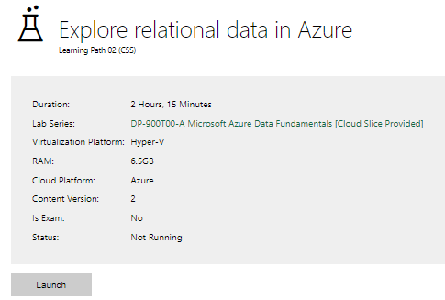

Completed lab | 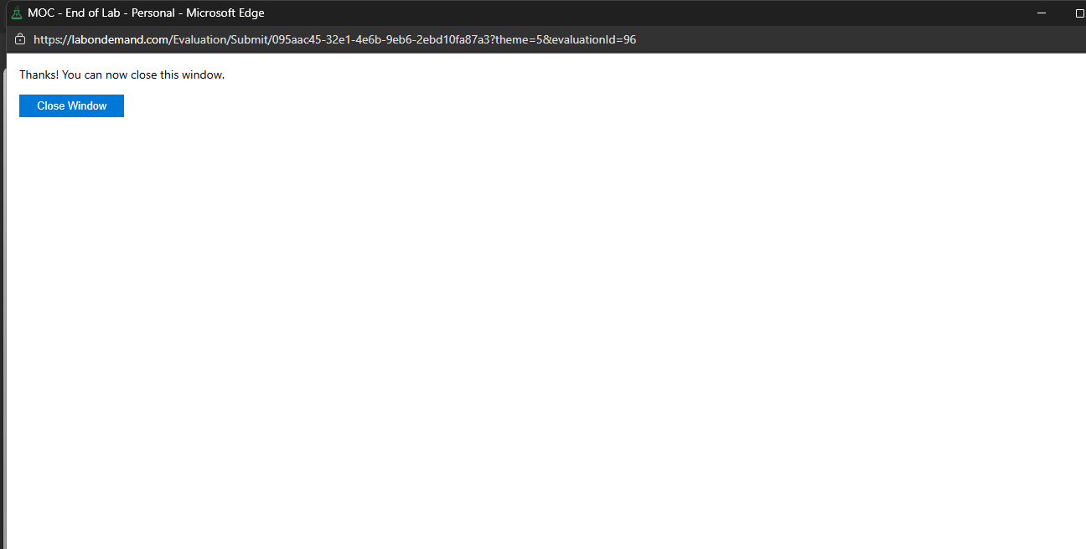

Day 3: Task 2

Please complete the below lab (4) ‘Explore non-relational data in Azure’ and paste evidence of the completed lab in the box provided.

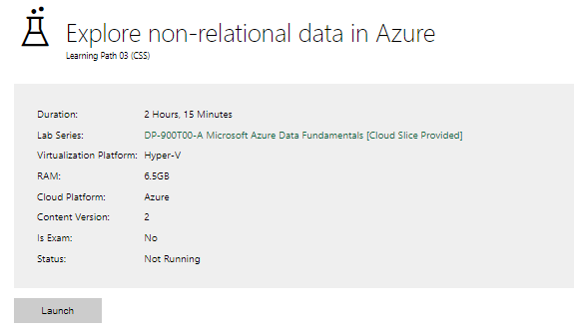

Completed lab | 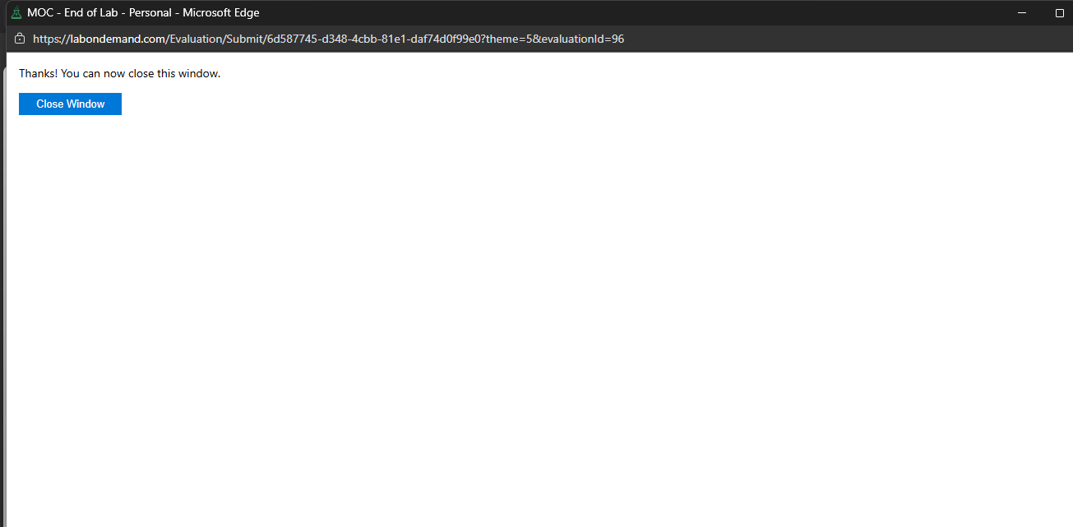

Day 3: Task 3

Please complete the below lab (5) ‘Explore data analytics in Azure’ and paste evidence of the completed lab in the box provided.

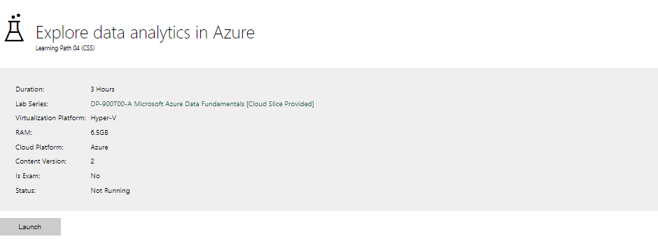

Completed lab | 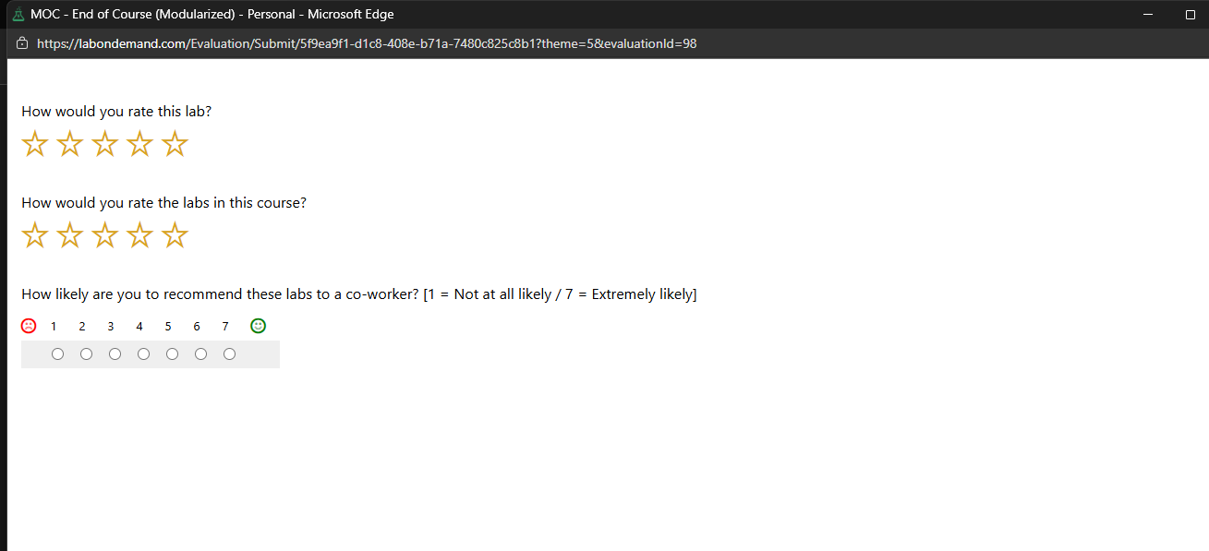

Day 4: Task 1

In your teams, complete the Azure DP-900 practice exam and paste your result below – this is open book and please research and discuss your answers as a team.

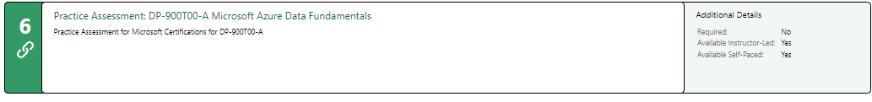
Result | 

Day 4: Task 2

1. Scenario Background
"Paws & Whiskers" is a growing pet shop that aims to improve its business by analysing sales, customer information, and inventory data. Currently, the data is collected manually or stored in spreadsheets. Management is interested in transitioning to Microsoft Azure to streamline data storage, analysis, and reporting, enabling them to make data-driven decisions.

2. Data Laws and Regulations
Identify and explain the data laws and regulations relevant to handling customer data within the proposal. Ensure you cover the following points:
- GDPR Compliance: Highlight the importance of adhering to the General Data Protection Regulation (GDPR), particularly as it relates to storing and processing customer information.
- Data Protection Act (DPA) 2018: Outline how the DPA 2018 may affect the way "Paws & Whiskers" collects and stores data, ensuring compliance with UK laws on data privacy.
- Other Industry Standards: Research any additional data protection standards or regulations that may apply to pet shop data, particularly if they involve sensitive or payment information.

3. Azure Service Recommendations
Recommend Microsoft Azure services that would suit the company’s data analysis needs and explain why these services are suitable. Your recommendations should include:
- Data Storage: Identify suitable storage options, such as Azure Blob Storage or Azure SQL Database, and discuss the benefits of each for storing large datasets, including inventory, sales transactions, and customer details.
- Data Analysis Tools: Recommend tools such as Azure Machine Learning for customer behaviour analysis or Azure Synapse Analytics for analysing sales trends.
- Data Integration and Automation: Explain how services like Azure Data Factory could automate data collection and integration processes, improving efficiency.

4. Data Types and Data Modelling
Define the types of data "Paws & Whiskers" will need to work with and describe your approach to data modelling:
- Data Categories: Identify key data types, such as customer demographics, transaction history, pet inventory, and product categories.
- Data Modelling Approach: Outline how you would structure this data using a relational model or a data warehouse approach, considering factors like tables, entities, relationships, and primary keys.

5. Data Storage Formats and Structures in Azure
Discuss how you would store data within Azure and the formats you would recommend:
- Data Formats: Specify recommended formats (e.g., CSV for raw data imports, JSON for structured data, Parquet for analytics) and explain why these formats are suitable for specific data types.
- Data Security and Encryption: Include recommendations for securing data using Azure’s built-in encryption features and access controls to ensure compliance with data privacy regulations.

6. Additional Considerations
Provide any other considerations that might enhance data handling and efficiency in Azure, such as:
- Backup and Disaster Recovery: Outline a backup plan using Azure Backup or Azure Site Recovery to safeguard against data loss.
- Data Visualisation: Discuss potential use of Power BI within Azure for creating dashboards that provide management with real-time insights into sales and customer trends.
- Future Scalability: Comment on how Azure services can scale as the business grows, accommodating larger datasets and more complex analyses.

Submission Guidelines:
- Structure: Ensure your report is well-organised, with sections for each task (e.g., Data Laws, Azure Services, Data Types, etc.).
- Formatting: Include headings, bullet points where appropriate, and any visuals or diagrams that support your explanations.
- References: Cite any resources or regulations referenced in the report.
- Length: Aim for 1500-2000 words.

Data Laws and Regulations
When handling customer information, paws and whiskers must follow several important rules to protect privacy and comply with the law.
1. GDPR Compliance
The General Data Protection Regulation (GDPR) applies to any business that collects or processes personal data of citizens for paws and whiskers this means collecting only information that is necessary, such as customer names, contact details, and purchase history. Customers should be able to access, correct, or request deletion of their data. The company must also protect data against unauthorized access or loss and report any data breaches to authorities and affected individuals within 72 hours they must also contact the ico within 72 hours.Following GDPR not only avoids fines but also helps build trust with customers.
. Data Protection Act 2018 (DPA 2018)
The UK Data Protection Act 2018 complements GDPR and sets UK-specific rules for managing personal data. Businesses must put proper security measures in place to protect information, keep records of how personal data is collected, stored, and used, and take extra care with sensitive data for example payment methods. For paws and whiskers this means ensuring spreadsheets, databases, and cloud systems are secure and that all staff handle data responsibly and abide by rules.
. Other Industry Standards
Other rules may apply depending on the type of data collected:
- PCI DSS (Payment Card Industry Data Security Standard): Ensures that any credit card information is stored and processed securely.
- ISO 27001: Provides general guidelines for managing and protecting all business data.
- UK e-commerce and retail regulations: Govern the safe handling of customer information collected online or in-store.
By following GDPR, the DPA 2018, and these additional standards, paws and whiskers can keep customer data safe, comply with legal requirements, and maintain customer confidence with ease.

Recommended Microsoft Azure Services
To help paws and whiskers manage and analyse its data efficiently, Microsoft Azure services would be suitable. These services can store large amounts of information, perform advanced analysis, and automate data handling.
1. Data Storage
- Azure SQL Database: This is ideal for structured data, such as customer information, sales transactions, and inventory records. It allows easy searching, filtering, and reporting, and can grow as the business expands.
- Azure Blob Storage: Best for unstructured data, like product images, CSV spreadsheets, or JSON files. Blob Storage is cost-effective and can handle very large files without slowing down operations.
- Azure Data Lake: This is suitable for more complex analytics, combining multiple data types for analysis. It is especially useful if the shop wants to run large-scale reports or predictive analytics in the future.
Using these storage options ensures that all types of data—structured and unstructured—are stored securely, organised efficiently, and easy to access when needed.
2. Data Analysis Tools
- Azure Synapse Analytics: Allows the company to combine data from multiple sources to spot trends, such as which products sell fastest in different seasons. It makes generating reports quicker and more accurate.
- Azure Machine Learning: Can predict customer behaviour, like which customers are likely to return or what products they might buy next. This can help the shop plan marketing or promotions effectively.
- Power BI: A user-friendly tool for creating dashboards and visual reports. Management can see sales, stock levels, and customer patterns at a glance, making decision-making faster and more informed.
These tools help turn raw data into actionable insights that can improve operations and boost sales.
3. Data Integration and Automation
- Azure Data Factory: Automates the process of collecting data from spreadsheets, POS systems, or suppliers. It can clean and transform the data, then load it into storage without manual effort.
- Azure Logic Apps or Azure Functions: Can be used to automate routine tasks, such as sending weekly sales reports, alerting staff when stock is low, or updating customer loyalty information.
Automation reduces human error, saves time, and ensures that the company always has up-to-date, accurate data ready for analysis.

This combination of storage, analysis, and automation services allows “Paws & Whiskers” to store data securely, gain valuable insights, and streamline operations, making the business more efficient and data-driven.

Data Types and Data Modelling
To effectively manage and analyse its operations, paws and whiskers will work with several types of data. Organising this data properly is essential for accurate reporting and decision-making.
1. Data Categories
The main types of data the shop will need include:
- Customer Data: Information such as names, contact details, loyalty program membership, and purchase history. This helps understand buying patterns and manage customer relationships.
- Transaction Data: Records of sales, including product IDs, quantities, prices, payment methods, and dates. This data is crucial for tracking revenue, trends, and stock movement.
- Inventory Data: Details of products in stock, including product names, categories, suppliers, and quantities. This ensures that the shop knows what is available and when to restock.
- Product Categories: Information about the type of product (e.g., pet food, toys, accessories), the species it is for (dogs, cats, birds), and pricing. This allows grouping products for reporting or promotions.
- Operational Data: Supplier contacts, delivery schedules, and staff records, which help in managing day-to-day operations efficiently.
2. Data Modelling Approach
A relational database or data warehouse approach is recommended to structure this data:
- Tables and Entities:
  - Customers table: CustomerID (primary key), Name, Email, Phone, LoyaltyID
  - Products table: ProductID (primary key), Name, CategoryID, Price, StockLevel
  - Transactions table: TransactionID (primary key), CustomerID (foreign key), ProductID (foreign key), Quantity, TotalPrice, Date
  - Categories table: CategoryID (primary key), Name, Description
- Relationships:
  - Each customer can have multiple transactions (one-to-many).
  - Each product can appear in multiple transactions (one-to-many).
  - Each product belongs to a single category (many-to-one).
- Data Warehouse Consideration:
  - Fact tables can store transaction data.
  - Dimension tables can store information about customers, products, and categories.
  - This structure supports fast and efficient queries for reports and analytics.
Using this modelling approach ensures that data is organised, relationships are clear, and the shop can generate insights efficiently/clearly.

Data Storage Formats and Security in Azure
Storing data correctly in Azure is essential for keeping it organized, secure, and easy to analyse.

1. Data Formats
Different types of data benefit from different storage formats:
- CSV (Comma-Separated Values): Ideal for importing raw data from spreadsheets or older systems. It is simple, widely supported, and easy to process. For example, past sales records from Excel can be imported as CSV files into Azure for analysis.
- JSON (JavaScript Object Notation): Suitable for structured or semi-structured data, such as customer profiles, product details, or API outputs. JSON makes it easy to store nested information, like a customer’s multiple addresses or order history.
- Parquet: Optimized for analytics and large datasets. It uses columnar storage, which makes querying big tables, like sales transactions over several years, faster and more efficient. Parquet is perfect for analysis in Azure Synapse Analytics or machine learning tasks.
Using these formats together ensures that all data—whether simple, structured, or large-scale analytics datasets—can be stored efficiently and processed quickly.

2. Data Security and Encryption
Protecting customer and business data is critical. Azure offers built-in tools and features to ensure data is secure:
- Encryption at Rest: Azure automatically encrypts data stored in SQL databases, Blob storage, and Data Lake using strong encryption methods. This means that if someone accessed the storage without permission, the data would be unreadable.
- Encryption in Transit: All data moving between systems or users is encrypted with TLS/SSL, protecting it from interception.
- Access Controls: Azure Role-Based Access Control (RBAC) allows management to give employees only the access they need. For example, a salesperson might see inventory and customer info but not sensitive payment details.
- Data Masking and Auditing: Sensitive information, like credit card numbers or personal customer identifiers, can be masked in databases. All access to sensitive data can be logged for auditing, helping meet GDPR and DPA 2018 compliance.
By choosing the right data formats and implementing strong security measures, “Paws & Whiskers” can safely store and manage its information in Azure while making it easy to access and analyse when needed.

Course Notes

It is recommended to take notes from the course, use the space below to do so, or use the revision guide shared with the class:

• Computer Misuse Act 1990 (1) → unauthorized access & modification
• Police and Justice Act 2006 (2) → creation/distribution of hacking tools, DoS attacks
• Copyright, Designs and Patents Act 1988 (3) → illegal distribution of recordings
• Copyright (Computer Programs) Regulations 1992 (4) → unlicensed software use
• Health & Safety (Display Screen Equipment) Regulations 1992 (5) → training for workstation safety
• Data Protection Act 2018 (6) → purpose limitation, retention, and accuracy of personal data
• Consumer Rights Act 2015 (7) → product must be fit for purpose
• Breaks for screen time → Not illegal (not legally mandated, only recommended guidance)

Additional Information

We have included a range of additional links to further resources and information that you may find useful, these can be found within your revision guide.

END OF WORKBOOK

Please check through your work thoroughly before submitting and update the table of contents if required.

Please send your completed work booklet to your trainer.

